Multi Language Support (I18N):
The main advantage of I18N is we can convert our Portal into diff languages.
Our portal supports minimum 20 Languages. When we are convert to One Language to another Language that time we can use I18N.

Go to User Administration-→Identity Management-→Search user=userb-→Select userb-→click on Modify--→Go to General Information Tab--→Here Change the Language =German
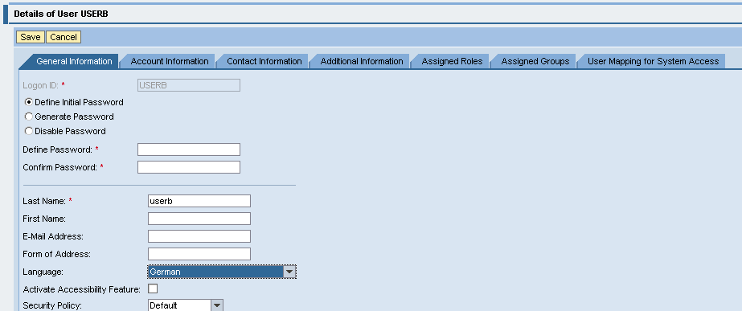

And Click on SAVE.

Now English language Convert to German Language.
This is Effect from Only Roles (Content, User and System Administrations) and work Set aslo.Only these Content data will convert to Germen Language.
But Our Role (AugestRole) Will not Conver to Germen Language.
How to Convert Particular Role like (AugRole) Convert to another Language.

- Create one Translation worklist and required Portal Objects Add to Translation work list. After add all Portal Objects then Release for Translation Data.
- After Release for Translation Data then search Translation worklistID and select that translationworklistid convert to source language to target language.
- Next Publish Translation data, it means that language is converting to source language to target language.
- Finally that selects particular user and change the language.
Imp is point is username language is equals to Translation worklist.both are same that time Translation worklist is convert to that language.

- Go to Content Administration --→Portal Content Translation-→ TranslationWorklistCordination -→ Portal Content- -→Select Folder (SapExamPro)-→RC New-→Click on Translation Work list
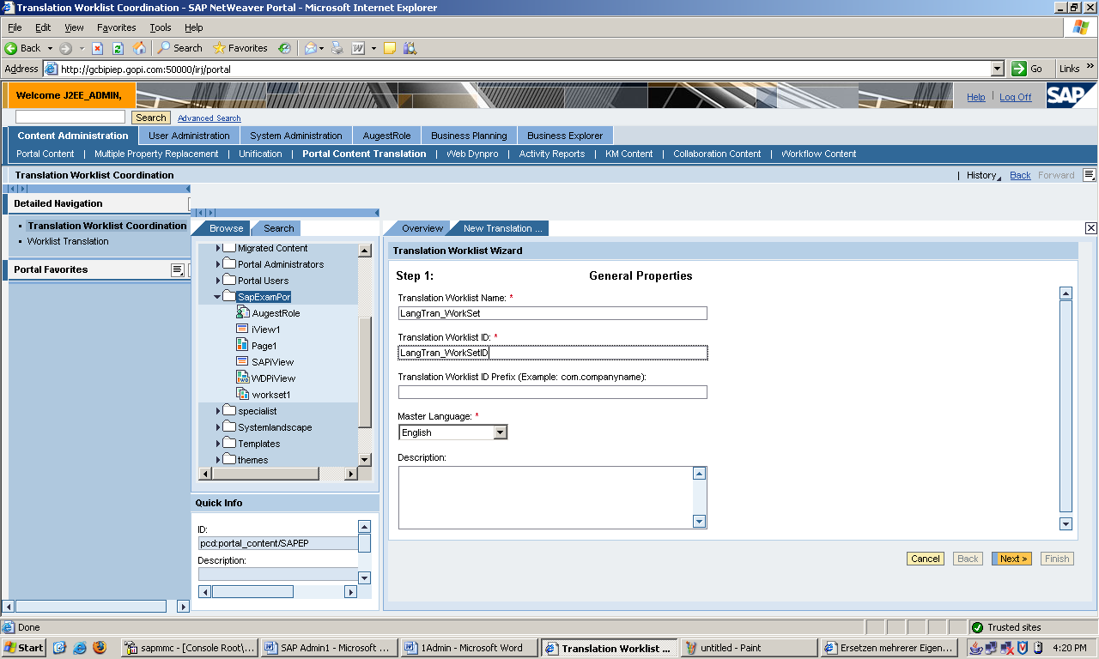

Here Enter Translation Worklist Name: LangTran_WorkSet
Translation Worklist ID: LangTran_WorkSetID-→Next-→Finish--→Select Open Object for Editing--→Click on OK Button.

- RC on iView, page1, work set1, AugestRole-→Click on Add Object to Translation work list.
- Now Click on General Translation data--→ Click on Release for Translation Data -→Click on Close button.
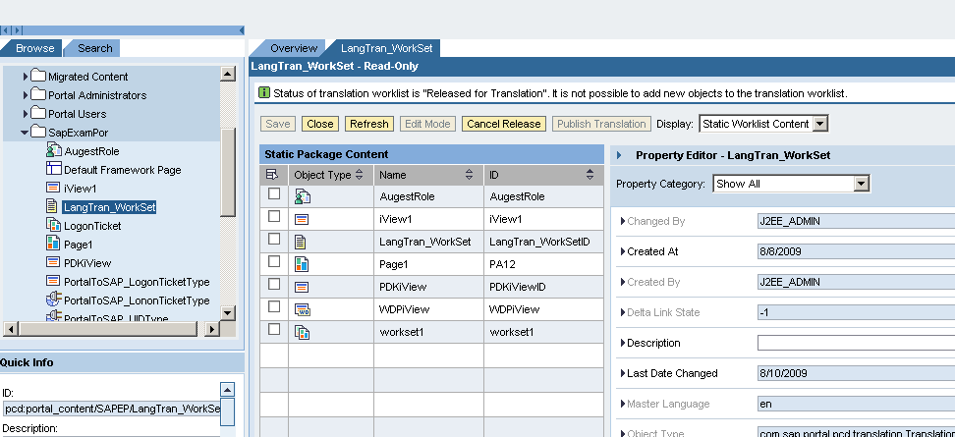

- Go to Content Administrator --→Portal Content Translation-→Work list Translation-→Here Search Worklist ID: LangTran_WorkSetID*-→Click on Search---→Select that work list (pcd:portal_content/SAPEP/LangTran_WorkSetID)

And Select Languages
Source Language: English
Target Language: Germen
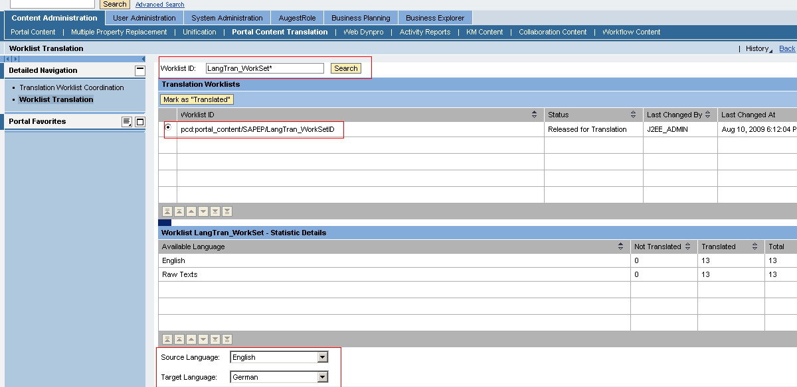

Next Click on Load for Translation
Go Target text--→Here Enter Language Name (Germen Language)--→Next--→

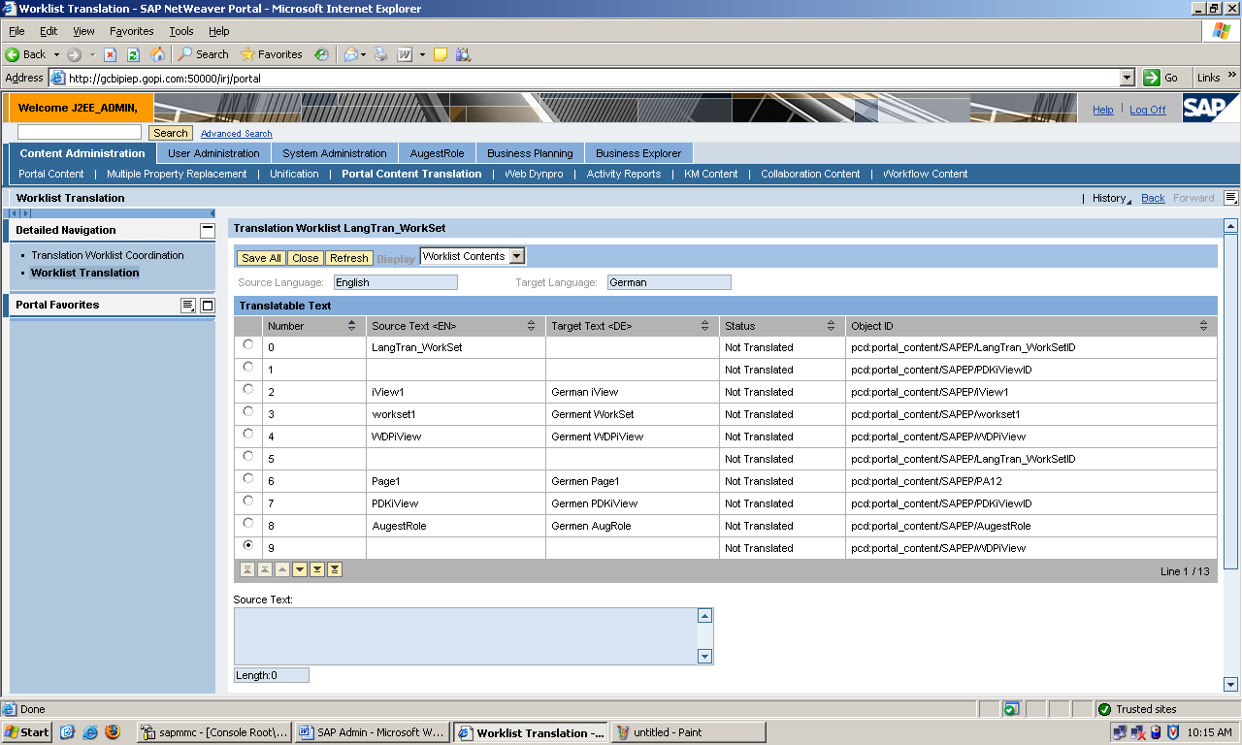

Click on SAVE ALL.

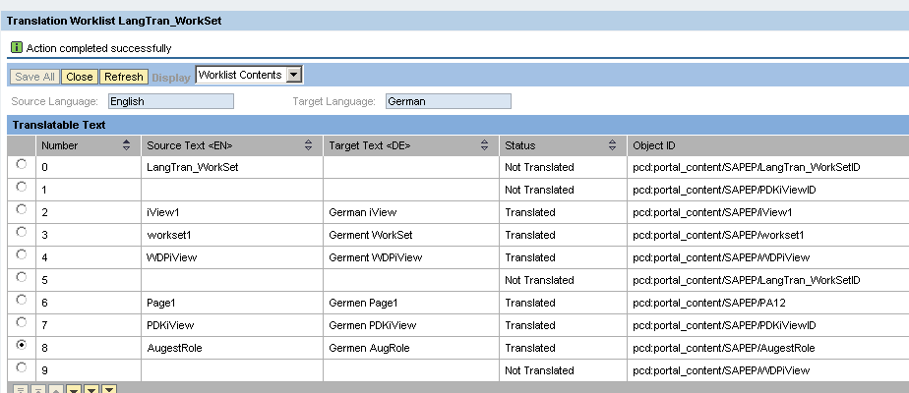

Click on Close--→Make as “Translated”.

- Again Content Administration --→Portal Content Translation --→Translation work list Coordination --→Portal Component--→ Go to Our Folder (SapExamPro)--→Work set (LangTran_Workset) --→ RC-→New-→Click on Object--→Next Click on Publish Translation.

Now go to particular users (usera, userb, userc). Just Change the Language. Depending up on what u need that Language
Work List Language = Portal User Language Both Are Same.

Its Completed go to usera check it AugestRole Converted to Germen language.

